SUPERMARKET MANAGEMENT SYSTEM

Title
Supermarket Management System Using Node.js, Express.js, and MongoDB

Objective
The objective of this project is to develop a backend-based Supermarket Management System that efficiently manages supermarket data including categories, customers, suppliers, and products. The system provides RESTful APIs for performing CRUD operations and demonstrates MongoDB database management using Mongoose.

Tools and Technologies Used
Tool / Technology | Version
Node.js | v24.x
Express.js | Latest
MongoDB | Latest
Mongoose | Latest
Postman | Latest
Visual Studio Code | Latest
dotenv | Latest
cors | Latest

Project Description
The Supermarket Management System is a backend application developed using Node.js, Express.js, and MongoDB. The application allows administrators to manage categories, customers, suppliers, and products through REST APIs.
MongoDB is used as the database for storing and retrieving information. Mongoose is used to create schemas and establish relationships between collections. The APIs were tested using Postman.
The system demonstrates CRUD operations including Create, Read, Update, and Delete functionalities.

Modules Implemented

1. Category Management
- Add Category
- View Categories
- Update Category
- Delete Category

2. Customer Management
- Add Customer
- View Customers
- Update Customer
- Delete Customer

3. Supplier Management
- Add Supplier
- View Suppliers
- Update Supplier
- Delete Supplier

4. Product Management
- Add Product
- View Products
- Update Product
- Delete Product

Database Relationships

One-to-Many Relationship
- One Category → Many Products
- One Supplier → Many Products
Relationships are implemented using MongoDB ObjectId references and Mongoose populate() functionality.

CRUD Operations Performed

Create
- Add Category
- Add Customer
- Add Supplier
- Add Product

Read
- View Categories
- View Customers
- View Suppliers
- View Products

Update
- Update Category Details
- Update Customer Information
- Update Supplier Information
- Update Product Information

Delete
- Delete Category
- Delete Customer
- Delete Supplier
- Delete Product

Output Screenshots

Screenshot 1: Project Folder Structure
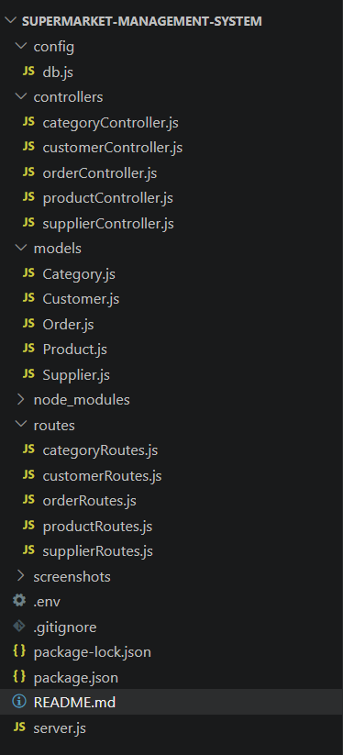
Explanation: This screenshot shows the overall project structure including models, controllers, routes, server configuration, and environment files.

Screenshot 2: MongoDB Database Collections
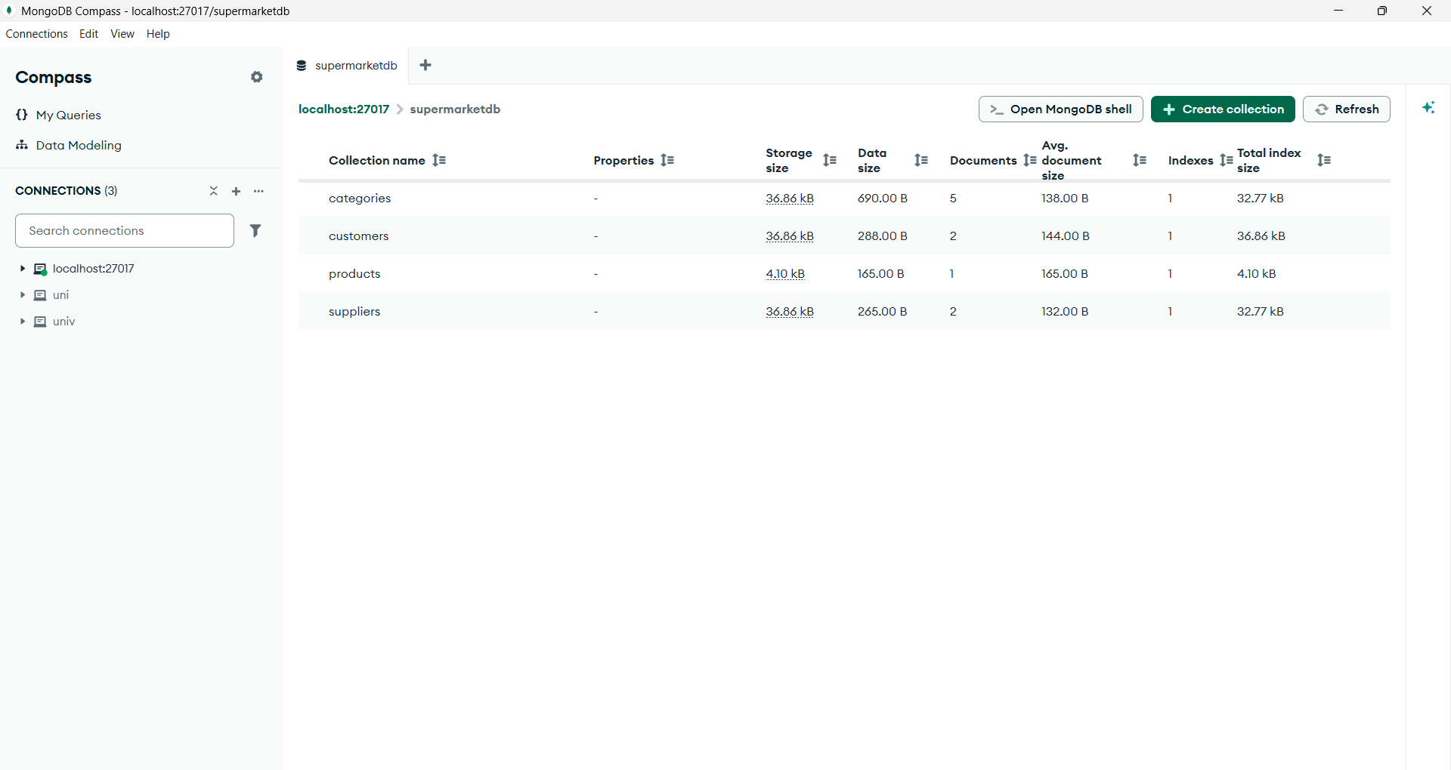
Explanation: This screenshot displays the MongoDB collections created for Categories, Customers, Suppliers, and Products.

Screenshot 3: Category API
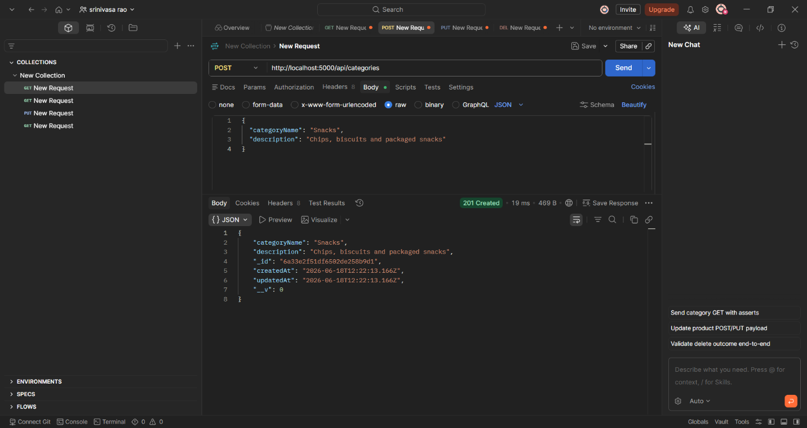
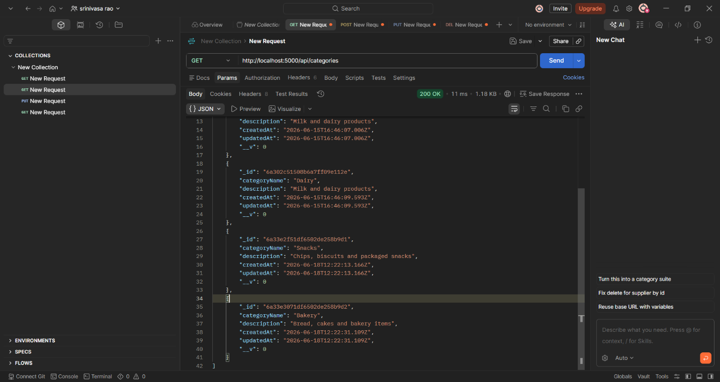
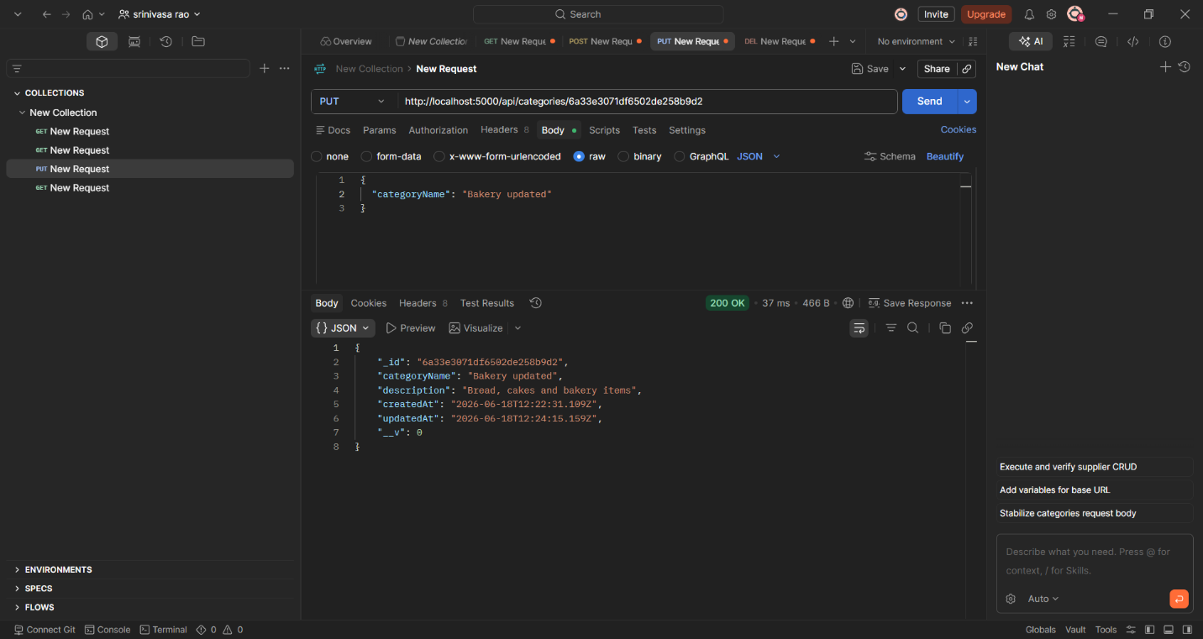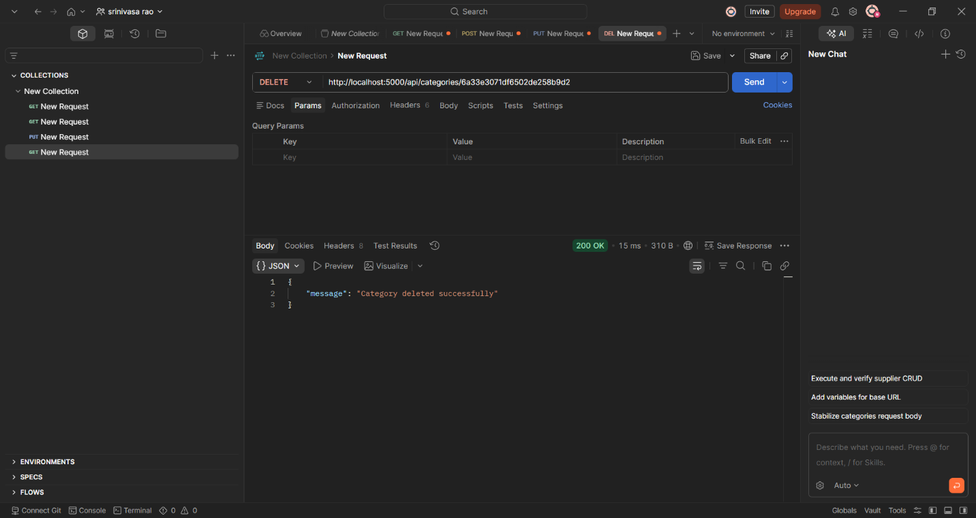
Explanation: This API is used for CRUD operations for category into the database.

Screenshot 4: Customer API
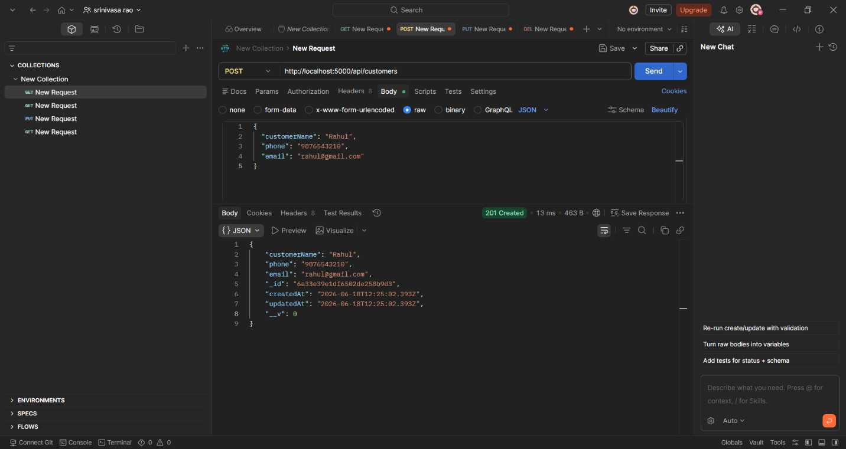
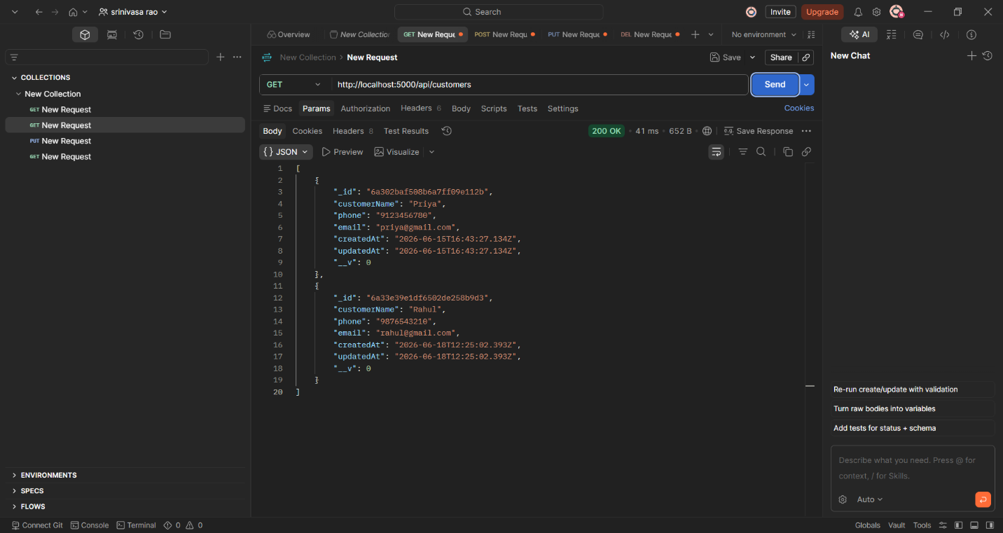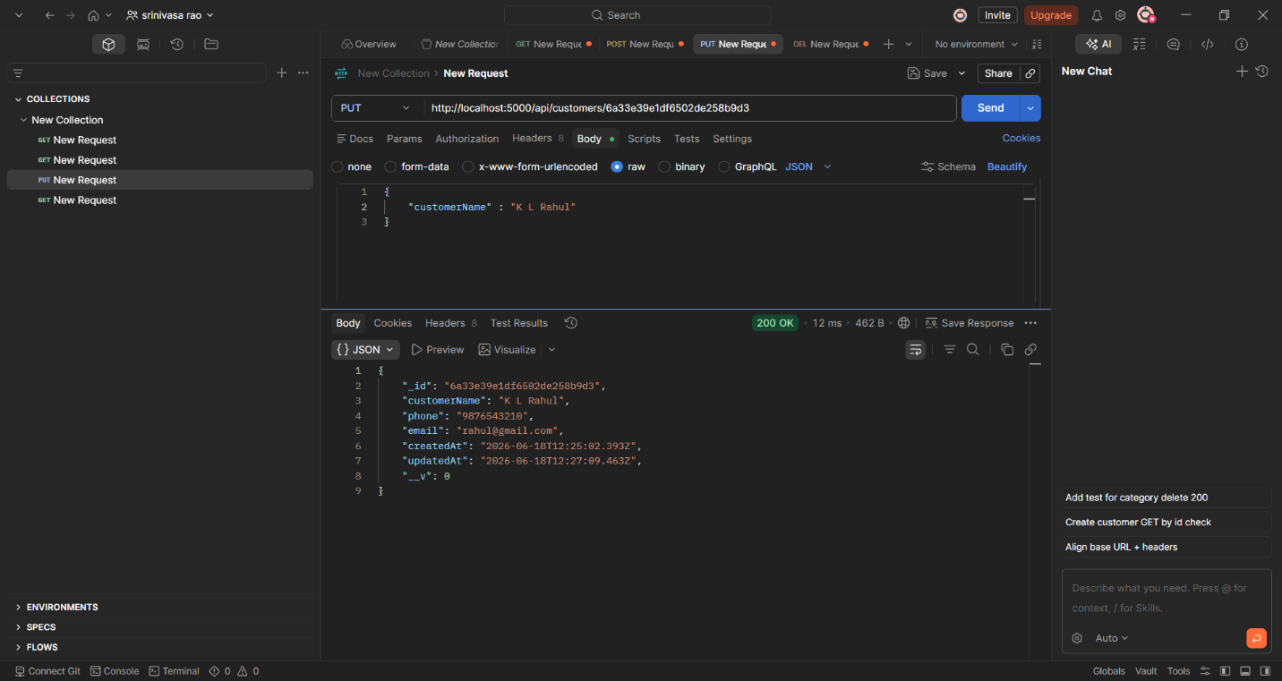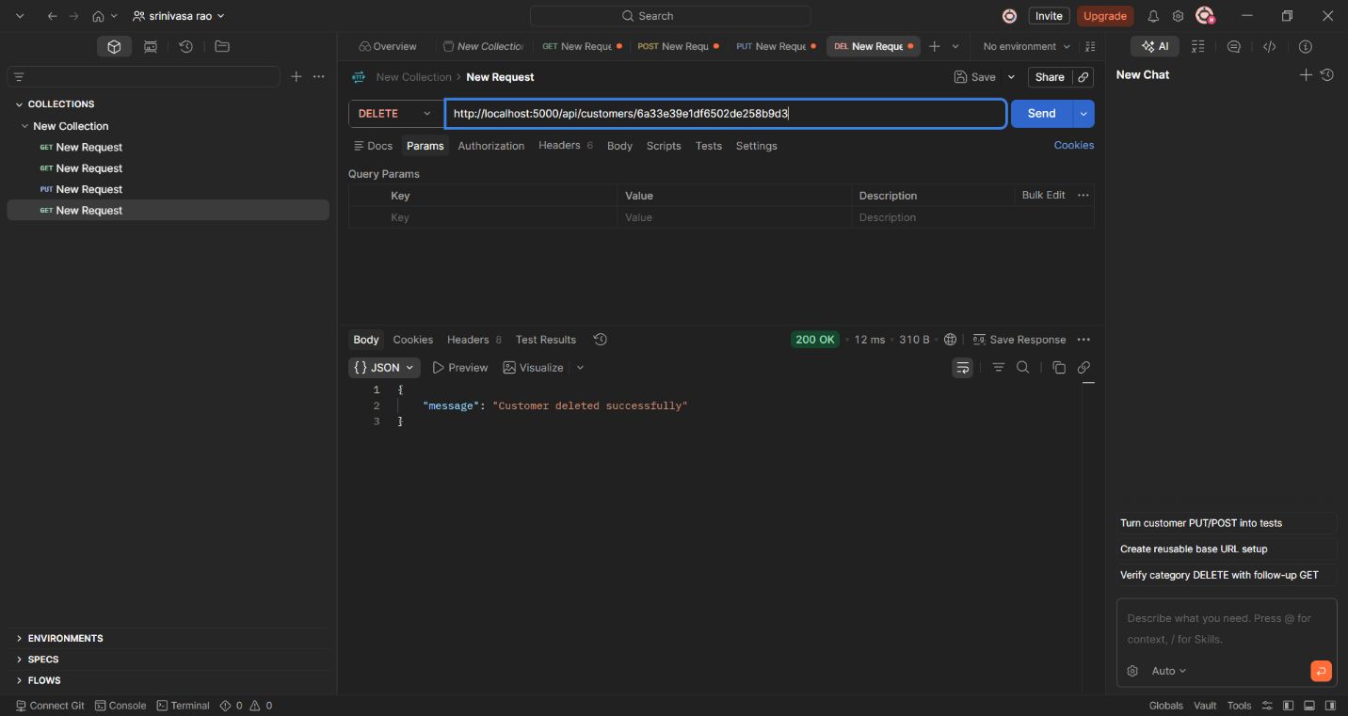
Explanation: This API is used for CRUD operations for customers into the database.

Screenshot 5:Suppliers API 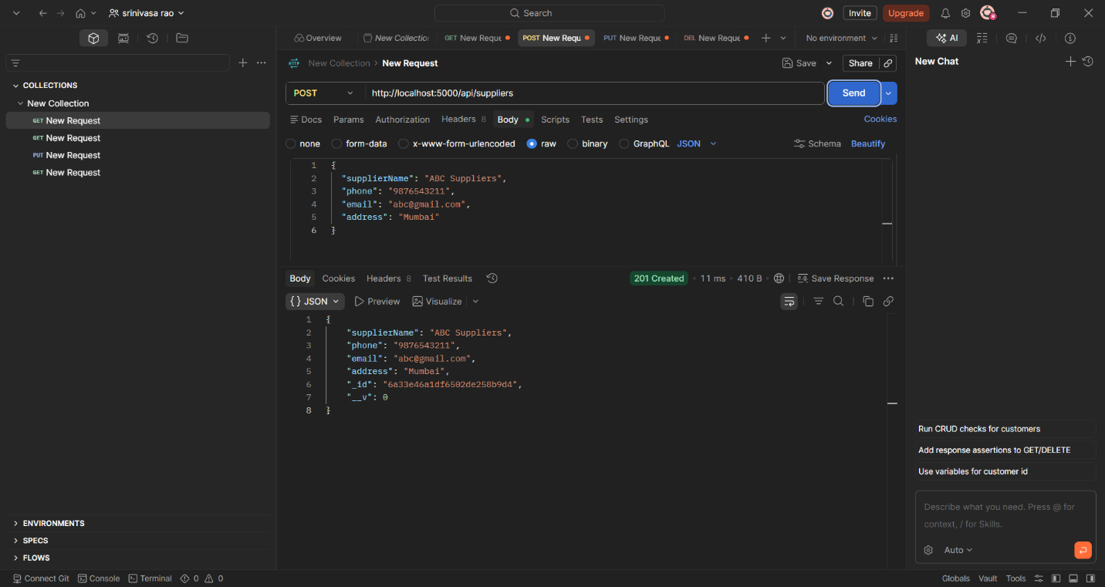
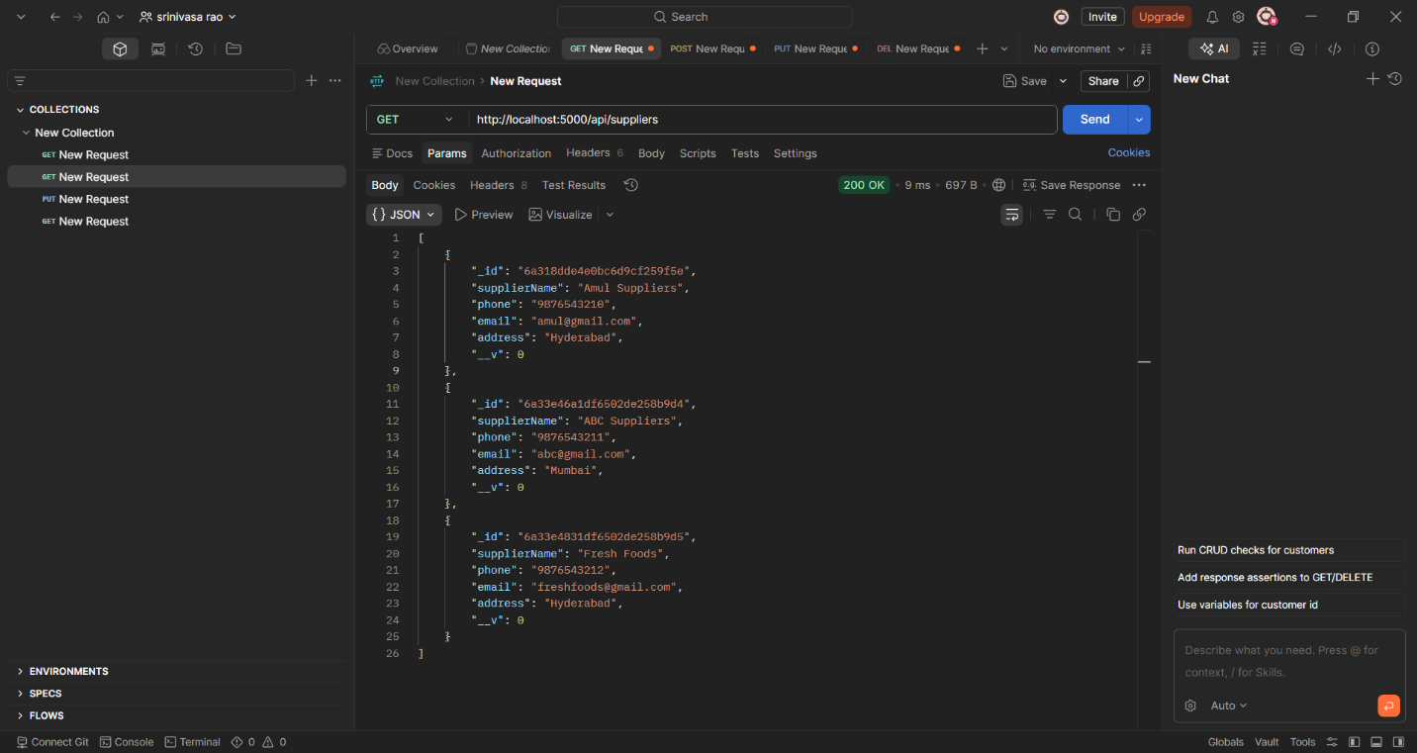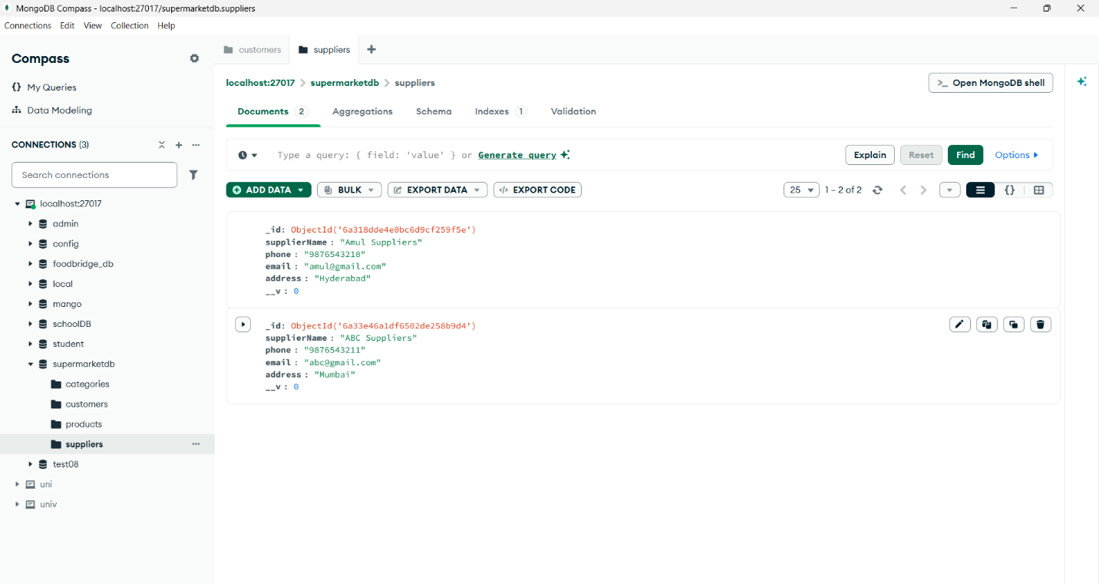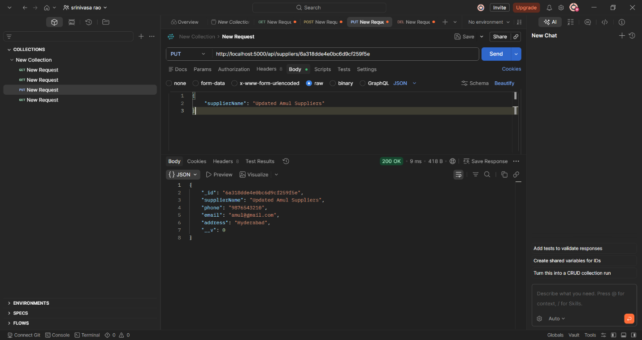
Explanation: This API is used for CRUD operations for supplier into the database.

Screenshot 6: Product API
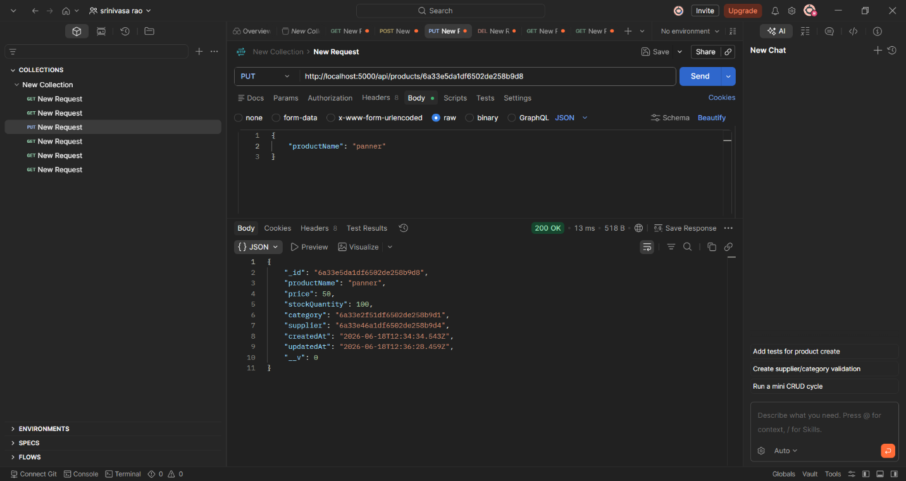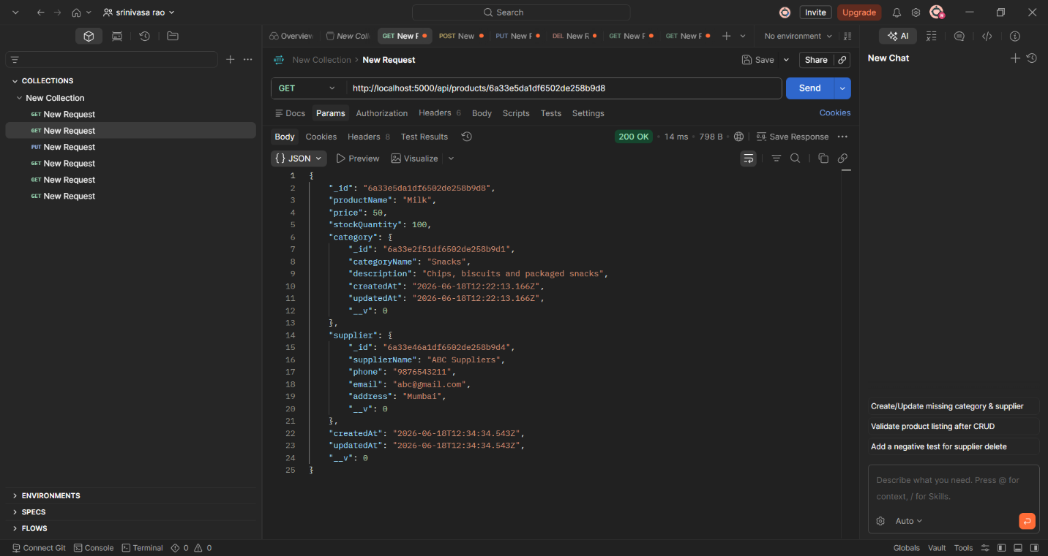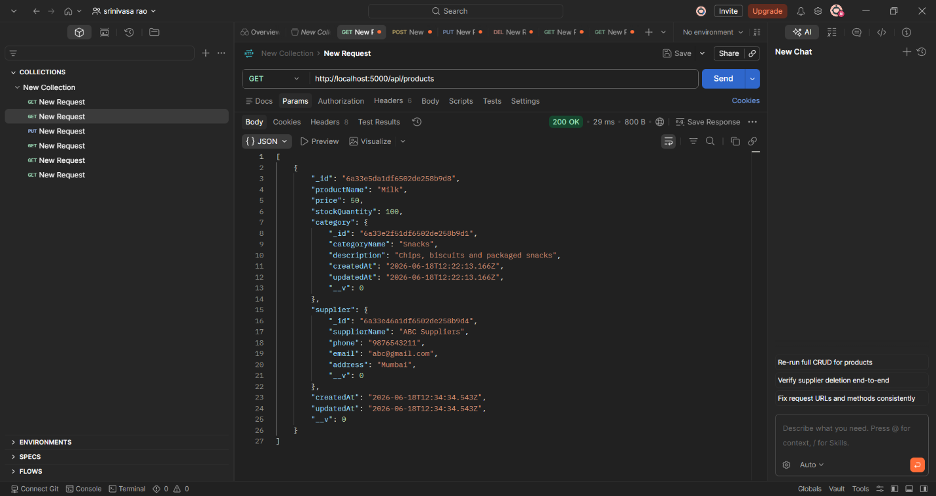
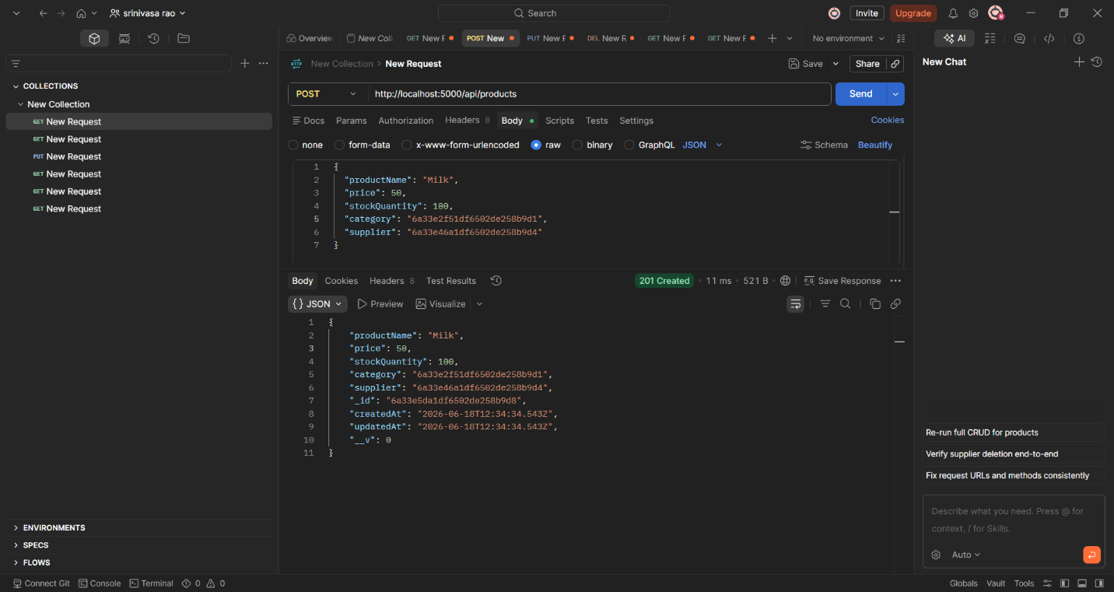
Explanation: This API is used for CRUD operations for product into the database.

Outcome
The Supermarket Management System successfully performs CRUD operations for Categories, Customers, Suppliers, and Products using REST APIs. The project demonstrates MongoDB database connectivity, schema creation, collection relationships, and backend API development using Node.js and Express.js. The APIs were successfully tested using Postman and data was stored and retrieved from MongoDB.

Summary
The project provides an efficient backend solution for managing supermarket-related data. It demonstrates practical implementation of NoSQL databases, RESTful API development, and Mongoose schema mapping. The system enables easy management of categories, customers, suppliers, and products while maintaining relationships between collections.

Conclusion
The Supermarket Management System was successfully developed using Node.js, Express.js, and MongoDB. The project helped in understanding backend development concepts such as API creation, database operations, collection relationships, and CRUD functionalities. The application provides a scalable and efficient foundation for future enhancements such as order management, inventory tracking, authentication, and frontend integration.

